Algorithm for file updates in Python
Balog David-Alexandru

Project description
In a healthcare organization, protecting patient information is critical. Access to restricted systems that contain personal patient records must be carefully controlled. One method used to manage this access is an allow list that contains IP addresses permitted to access the restricted network.
However, employees may change roles or leave projects involving patient data. When this happens, their IP addresses must be removed from the allow list to maintain security. Manually updating the file each time could lead to mistakes and inefficiencies.
To solve this problem, I developed a Python algorithm that automatically checks whether any IP addresses in a remove list appear in the allow list. If an IP address appears in both lists, the algorithm removes it from the allow list and updates the file. This ensures that only authorized IP addresses can access restricted healthcare data.

Open the file that contains the allow list
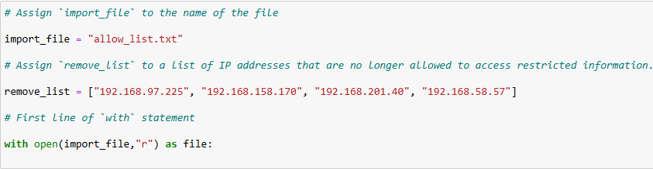

The first step of the algorithm is to open the file that contains the allow list of IP addresses. The file is named "allow_list.txt", which stores the IP addresses that are allowed to access restricted patient data.
First, I assigned the name of the file to a variable called import_file : import_file = "allow_list.txt".
This line creates a string variable that stores the file name. Using a variable allows the program to reference the file later in the algorithm. Next, I used a with statement together with the open() function to open the file: with open(import_file, "r") as file:. The with keyword is used to safely open a file and automatically close it after the code block finishes running. This helps manage system resources and prevents file access errors.
The open() function is used to open files in Python. It takes two main arguments: the file name (import_file) and parameter (“r”). The "r" argument means read mode, which allows the program to read the contents of the file but not modify it. The as keyword assigns the opened file to the variable file. This variable is used inside the with statement to interact with the file. This step prepares the algorithm to read the list of IP addresses stored in allow_list.txt so they can be processed later in the program.

Read the file contents
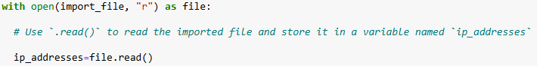
After opening the allow list file, the next step in the algorithm is to read the contents of the file so the IP addresses can be accessed and processed by the program.
To accomplish this, I used the .read() method inside the with statement: ip_addresses = file.read().
The .read() method reads the entire contents of the file and converts it into a string. In this case, the method is applied to the variable file, which represents the opened file.
The result of the .read() method is stored in the variable ip_addresses. This variable now contains all the IP addresses from the allow list file as a single string.
Storing the contents of the file in the ip_addresses variable allows the algorithm to access and manipulate the data later in the program.

Convert the string into a list
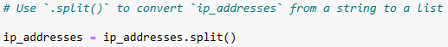
After reading the contents of the allow list file, the IP addresses were stored in the variable ip_addresses as a string. However, removing individual IP addresses from a string is difficult because the addresses are all stored together as one block of text. To solve this problem, I converted the string into a list using the .split() method : ip_addresses = ip_addresses.split().
The .split() method is a Python string method that separates a string into a list of elements. By default, .split() divides the string wherever there is whitespace, such as spaces or line breaks.
In the allow list file, each IP address is separated by whitespace. Because of this, the .split() method automatically separates the string into individual IP addresses and stores them as elements in a list.
After using .split(), the variable ip_addresses now contains a list of IP addresses instead of a single string. Converting the string into a list makes it easier to manipulate the data. Lists allow the program to iterate through each IP address and remove specific elements when necessary.

Iterate through the remove list
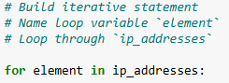
After converting the IP addresses into a list, the next step in the algorithm is to iterate through the list so that each IP address can be checked. To do this, I used a for loop: for element in ip_addresses.
The for keyword starts the loop. The variable element is the loop variable. It temporarily stores the value of each IP address during each iteration of the loop. The in keyword specifies that the loop should iterate through the sequence that follows it. ip_addresses is the list that contains the IP addresses read from the allow list file.
During each iteration of the loop, the variable element represents a different IP address from the list. This allows the program to examine each IP address individually.
A for loop is used in Python to repeat a set of instructions for every element in a sequence, such as a list.

Remove IP addresses that are on the remove list
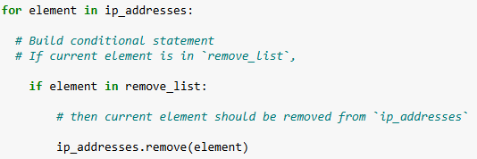
The next step of the algorithm is to remove any IP addresses from the allow list that appear in the remove list. These IP addresses should no longer have access to restricted content. To accomplish this, I used a conditional statement inside the for loop: if element in remove_list:.
The if statement is used to evaluate a condition. In this case, the condition checks whether the current IP address stored in the loop variable element exists in the remove_list. The in operator is used to determine whether a value is present within a sequence such as a list. If the IP address currently being examined is found in remove_list, the condition evaluates to True.
When the condition is true, the algorithm uses the .remove() method: ip_addresses.remove(element).
The .remove() method deletes the specified element from the list. In this algorithm, it removes the unauthorized IP address from the ip_addresses list.
By combining the for loop, if statement, and .remove() method, the algorithm ensures that any IP addresses listed in remove_list are removed from the allow list.

Update the file with the revised list of IP addresses
After removing the unauthorized IP addresses from the list, the final step of the algorithm is to update the allow list file with the revised list of IP addresses. Before writing the data back into the file, the list must be converted back into a string. To accomplish this, I used the .join() method: ip_addresses = “ ”.join(ip_addresses).
The .join() method combines all elements in an iterable, such as a list, into a single string. The method is applied to a string that defines the separator between elements. In this case, a space " " is used so that each IP address in the list is separated by a space when converted into a string.
After converting the list back into a string, the next step is to update the original file. To do this, I used another with statement together with the open() function.
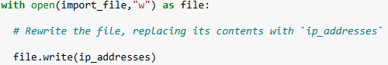
In this case, the "w" argument is used with the open() function. The "w" parameter stands for write mode, which allows the program to overwrite the contents of the file.
The .write() method writes the updated string of IP addresses to the file. When this code runs, the previous contents of the allow list file are replaced with the revised list that no longer includes the unauthorized IP addresses.
This step completes the algorithm by ensuring that the file containing the allow list is updated and that only authorized IP addresses remain.

Summary
In this project, I developed a Python algorithm to update a file containing IP addresses that are allowed to access restricted content within a healthcare organization. The purpose of the algorithm is to ensure that only authorized employees can access systems that contain sensitive patient information.
The algorithm begins by opening the allow_list.txt file and reading its contents using the .read() method. The contents of the file are stored in a variable and then converted from a string into a list using the .split() method. Converting the data into a list makes it easier to work with individual IP addresses.
Next, a for loop is used to iterate through the list of IP addresses. During each iteration, a conditional statement checks whether the current IP address appears in the remove_list. If the address is found in the remove list, the .remove() method is used to delete it from the allow list.
After removing the unauthorized IP addresses, the updated list is converted back into a string using the .join() method. Finally, the file is opened in write mode and the .write() method is used to overwrite the file with the revised list of authorized IP addresses.
By automating this process with Python, the algorithm helps maintain accurate access controls and improves security by ensuring that only approved IP addresses can access restricted healthcare data.

